Sara Steele committee meeting report, 5/29/2013

Intention: to develop computational models that describe and predict phenomenology (perceptual reports) of auditory stream segregation.

* I have learned statistical and dynamical modeling techniques to describe perceptual phenomena of buildup and alternation;
* future directions include incorporating more mechanistic, stimulus driven processes, fleshing out the link between stimuli and phenomenology
* I intend to lay the groundwork for this research during the month of July, during which I will be participating in Cold Spring Harbor Asia’s summer course on Cognitive and Computational Neuroscience
* My prior work is being written up for submission to a computational journal; I have previously presented a poster at SFN based on this research with preliminary psychophysics
* coursework is complete; I have only officially TA’d one class and would like to have at least one more teaching position before I graduate. I would especially like to TA math tools with Eero, but BINS or INTRONS would also be acceptable.

What is buildup?

Buildup of stream segregation is the increase in probability over time of a stimulus with distinct features being perceptual grouped into segregated streams. In the lab, buildup is most famously demonstrated using the van Noorden ABA_ (“horse-morse”) stimulus, in which a repeating sequence of pure tones can sound either like triplets with a galloping rhythm (“horse”) or split into two beep trains at two distinct frequencies and isochronous rhythms (“morse”). Other simple stimuli known to elicit buildup include ABAB trills. The perception of one or the other of these percepts depends on the separation in logarithmic frequency between the tones A & B, the presentation rate, and-- because of buildup-- the time since the stimulus is turned on. 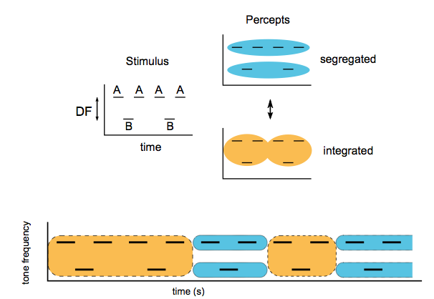

The conventional account is that the auditory system accumulates evidence over time in order to form distinct representations of the various objects in a room (Bregman, 1990).

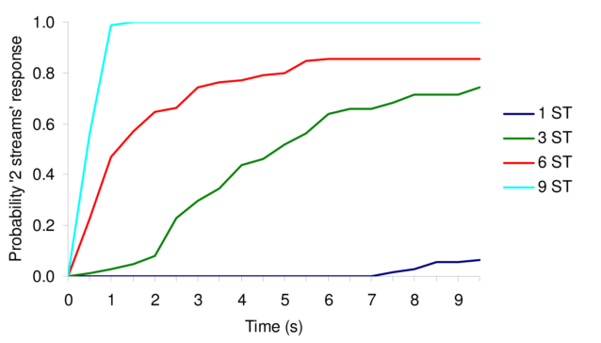

from Micheyl et. al., 2007.

...except buildup doesn’t seem to proceed uniformly towards a perfectly segregated state. The red curve above asymptotes at about 80% segregation after 5-6 seconds. This could in principle be because peripheral channels sometimes fails to ever become selective enough to distinguish the two tones as separate sources-- however, we believe that the asymptote instead reflects a steady state in which there are alternations back and forth between the integrated and segregated perceptual state (Pressnitzer & Hupe, 2006; Anstis & Saida, 1985). That is, buildup is not always a uni-directional process in which a wall of sound is decomposed into its distinct sources; rather, in a fixed auditory environment there can be alternations between hearing “the whole” and “its parts”. This is ecologically harder to justify in terms of an ideal observer; however, there is some intuitive description of such alternations occurring. To borrow heavily from a conceptual framework developed by Douglas Hofstadter, one can listen to a a fugue both holistically, as a unified object, or by focusing in on one or a few of its distinct voices-- but never simultaneously. Rather, the unique experience of listening to a fugue comes from switching back and forth between the two listening modes. In terms of the cocktail party, one often has to ask a speaker to repeat himself when segregation suddenly gives way to a cacophonous wall of sound.

**We were interested in understanding the multidirectional nature of buildup, and in exploring how the steady state might not reflect a fixed percept as a *fait accompli* of a teleological process of accumulation; rather, the multistability of perception might have a strong determining role in the phenomenology of buildup.**

We start with assumptions that do not explicitly invoke accumulation:

1) A listener in a particular auditory environment is capable of perceiving *distinct* and *mutually exclusive* interpretations of that environment in terms of the segregation of different sound components

2) The listener’s initial percept is typically a unique integrated interpretation of that environment

3) In a stable scene with no particular instructions or volitional goals, the listener’s subjective experience of the scene will naturally vacillate between different possible interpretations, with epoch durations described by stationary probability distributions.

Prior work:

Our lab has worked with and developed some existing pseudo-neuronal models to describe the phenomenology of perceptual bistability. We modified those competition models (Wilson & Cowan, Laing & Chow, Shpiro et. al., 2009) to simulate buildup.

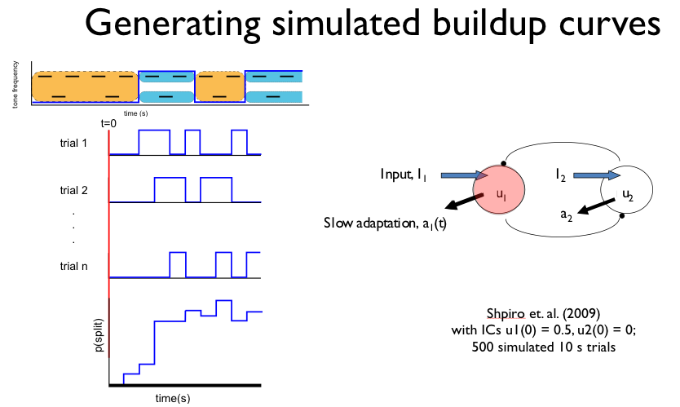

1. Buildup with dynamical competition firing rate models: By setting the initial conditions such that the neural population representing integration was always dominant first, we were able to produce buildup curves. Buildup occurs in a system which produces regular alternations; we tested this model within the parameter range established by Shpiro et al 2009 which comes closest to reproducing the statistical properties of alternations reported by observers for ambiguous plaid stimuli (which are similar to the statistics reported for bistable ABA_ percepts, Pressnitzer & Hupe 2006.)

From Shpiro et. al., 2009. Green area of parameter space produces percept duration statistics (mean, circular variance) consistent with psychophysical data.

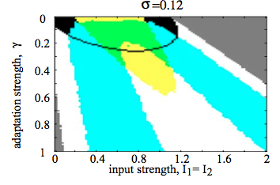

I did one set of simulations with parameters from within the regime producing statistics consistent with perceptual reports:

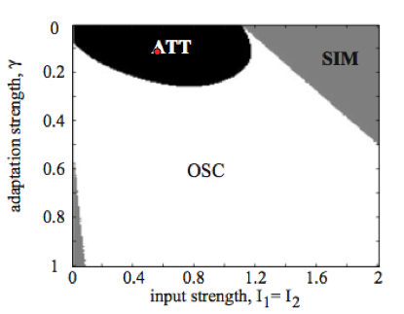

Buildup for I_1 = I_2 = 0.6, adaptation strength G = 0.1:

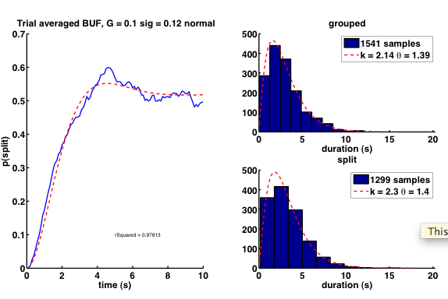

For unequal inputs:

I1 = 0.58, I2 = 0.62 I1 = 0.62, I2 = 0.58

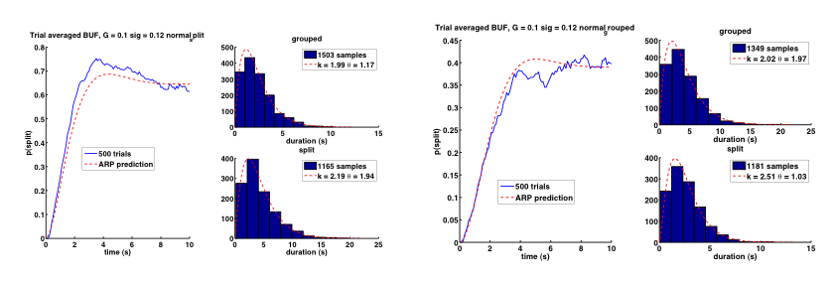

In the attractor domain, some reasonable looking buildup functions are achieved through this methodology. We don’t get perfect monotonicity, but I have actually collected buildup functions from individuals that are not monotonic: (100 trials, subject BH)

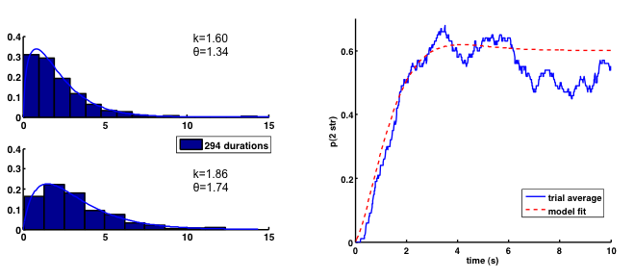

Psychophysical data, subject BH.

Averaging many non-monotonic buildup functions together, however, could create artifactually monotonic buildup curves.

Because we were interested in what would happen if percept-to-percept correlations were present, we also ran a set of simulations in the parameter regime in which alternations between perceptual states are driven by adaptation. Here, the adaptation strength is 0.3, compared to 0.1 above:

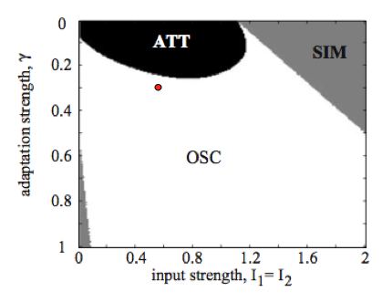

In line with the findings of Shpiro et al, not only are the statistics for the dominance durations produced under these parameters inconsistent with psychophysical data, the buildup functions produced here are extremely unusual:

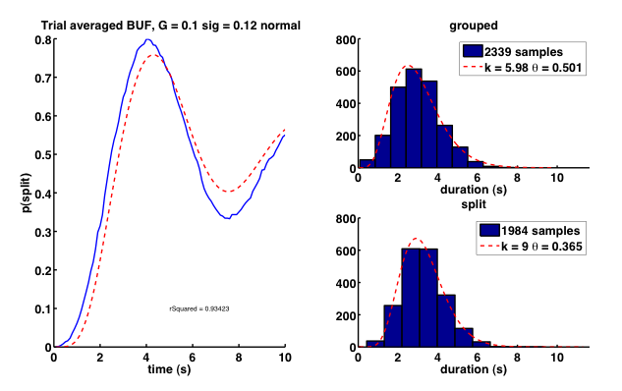

In principle, there could be buildup functions that look like this, but I’ve never seen them. Thus if buildup is a product of alternations, they are probably noise-driven alternations.

Some other observations from this investigation:

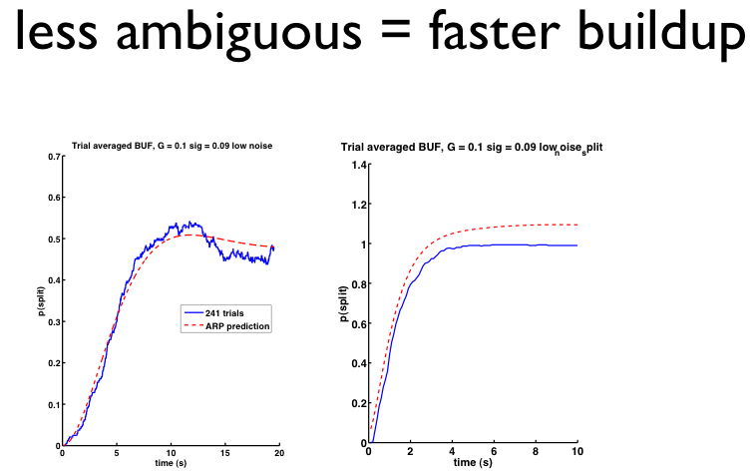

On the left, I1 = I2 = 0.6—the same parameters as the first simulation, but with less noise so that alternations occur more slowly. On the right, I1 = 0.58, and I2 = 0.62. This simulates a stimulus that is less ambiguous—rather, perception is strongly biased towards segregation. Although mean durations are shorter for highly ambiguous stimuli, buildup takes longer.

Also, the weaker the mechanism of alternation, the longer buildup takes to occur. I want to link this to some of Nava Rubin’s work with plaids and first percepts but I’m not sure how much of that has been published.

I also looked at the durations of the first percepts here, which is sadly inconsistent with the reported psychophysical data (but I believe easily remedied):

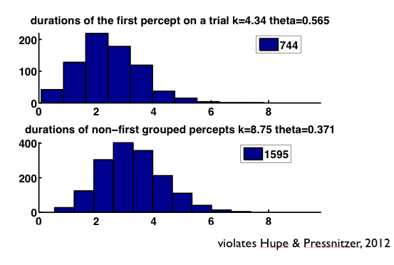

By the principle of “inertia” described in Hupe & Pressnitzer, 2012, the initial percept is actually supposed to be longer. I believe I can easily produce this behavior by simply implementing my first-dominant method by setting the initial condition on adaptation of the first-suppressed population at an intermediate level, rather than setting the initial condition on the response of the first dominant population:

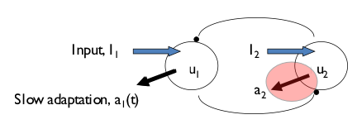

Future directions for these competition models follow two motivations: I would like less arbitrary way of fixing the initial percept, one which is based in some way on the features of an actual stimulus. In addition, there is some literature on fitting parameters for these types of models to behavioral data (Pastukhov et. al., 2013).

2. Buildup formally as an alternating renewal process:

Buildup is thought to reflect the accumulation of evidence by the sensory system to support the representation of multiple objects in a complex scene, or alternatively the accumulation of multi- second habituation of the neurons processing acoustic inputs. However, we show that this need not be the rule for the neural hardware underlying the subjectively sudden, stochastic switches between perceptual states; alternatively, the apparently gradual increase in probability of a split percept over time could be the averaging over many trials of a process that switches suddenly, but randomly, from a known starting state, and then alternates.

The analytical solution we have formulated for buildup has the possibility, in principle, to allow us to interconvert between the gradual buildup functions produced by averaging and the mutually exclusive perceptual states that describe a given trial. This would allow us to extract from a smooth function the parameters of the gamma densities for the durations of each percept; unfortunately, the present formulation of the ARP solution does not allow us to predict the parameters of the densities for the binary states whose alternation produces smooth buildup curves. We still believe the approach could be valuable because 1) it is very novel, 2) it suggests gradual accumulation might not, actually, be necessary for what looks like gradual buildup to occur, and 3) we could predict what the statistics of discrete events that occur suddenly, but stochastically, should be, as well as finding steady-state dynamics from short trials.

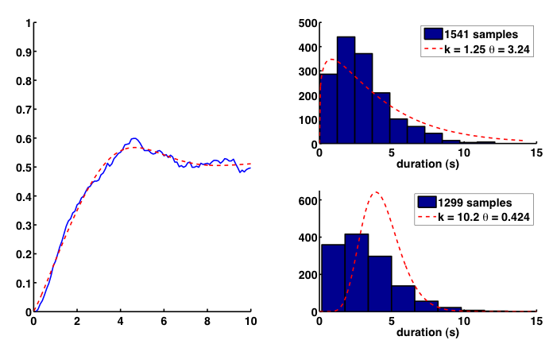

3. Future work: Build an auditory system (or something like it)

There are two stimulus specific effects that we have been interested in accounting for:

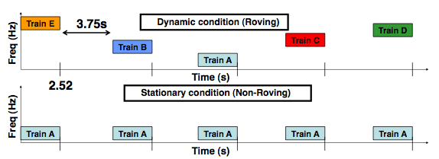

From J. Sussman’s poster for SFN.

**Reset:** If a stimulus train is stopped, and then started up again, buildup does not reset to zero. However, this reset relies on the stimulus starting back up in the same frequency band as the previous one. If the stimulus is roving, that is, a 6 st DF stimulus centered at 440 Hz followed by a 6 st DF stimulus centered at 880, then buildup resets.

This suggests that the segregation state is reliant on the specific stimulus features that have been segregated, and some information is carried by the peripheral channels. This makes sense ecologically-- stimulus identity is part of the formation of the stream. However, the data for this is primarily electrophysiological, in the form of the presence or absence of a mismatch negativity for intensity deviants in the B stream-- I don’t know if there is psychophysics to the same effect, but I suspect it should follow.

So, the integrated vs segregated competition should be frequency band specific.

A second somewhat paradoxical effect of interest is described in Snyder et. al., 2009-

If an ambiguous tone sequence (DF = 6 st) is presented after a tone sequence with a different DF (DF = 3 or DF = 12), the perception is biased *repulsively* from the previous interval. That is, for a sequence in the first interval in which DF = 3 (for which perception is biased towards integration) the perception of a the test stimulus at DF=6 is very strongly biased towards *segregation*, in comparison to when the test is preceded by silence.

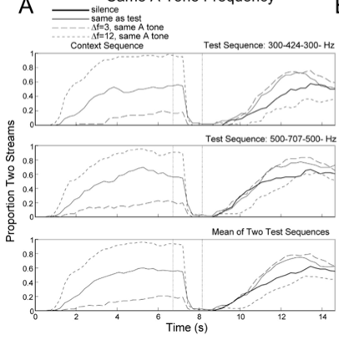

From Snyder et. al., 2009.

This repulsive bias is in contrast with a smaller, attractive effect of prior percept:

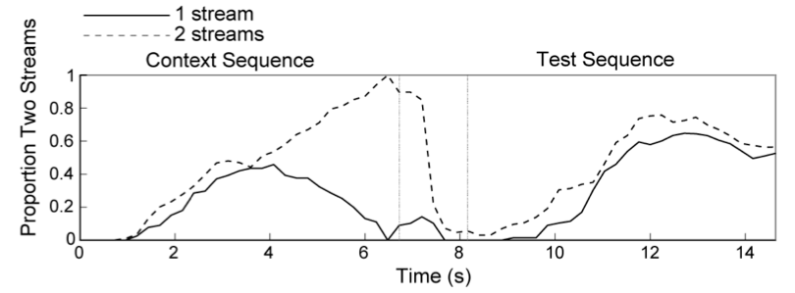

From Snyder et. al., 2009.

Here, if you condition the context sequence on whether it ends with a percept of segregation or integration, the test sequence evokes percepts which are slightly biased towards consistency with prior percept.

These findings require modeling of feature detectors to explain. I would like to design a model that parsimoniously accounts for all of these findings. I intend to develop this project during my summer school in Beijing, but I can outline my intuitions right now.

My first attempt at parsimoniously explaining these findings under a unified framework will be:

* A network of model feature-detectors in the form of frequency specific interval-selective neurons that undergo adaptation. Such neurons have been found in auditory cortex.
* The output of these feature detectors will be fed into a classifier that determines the strength of the cues for each of the possible grouping percepts- segregation or integration. This could take the form of a stimulus similarity index.
* If this model is successful in accounting for the previously reported experimental results, then I can use it to predict the outcomes of novel psychophysical experiments, such as interval discrimination following exposure to the ABA stimulus.